Web Deployment on Tomcat Server using Jenkins CICD
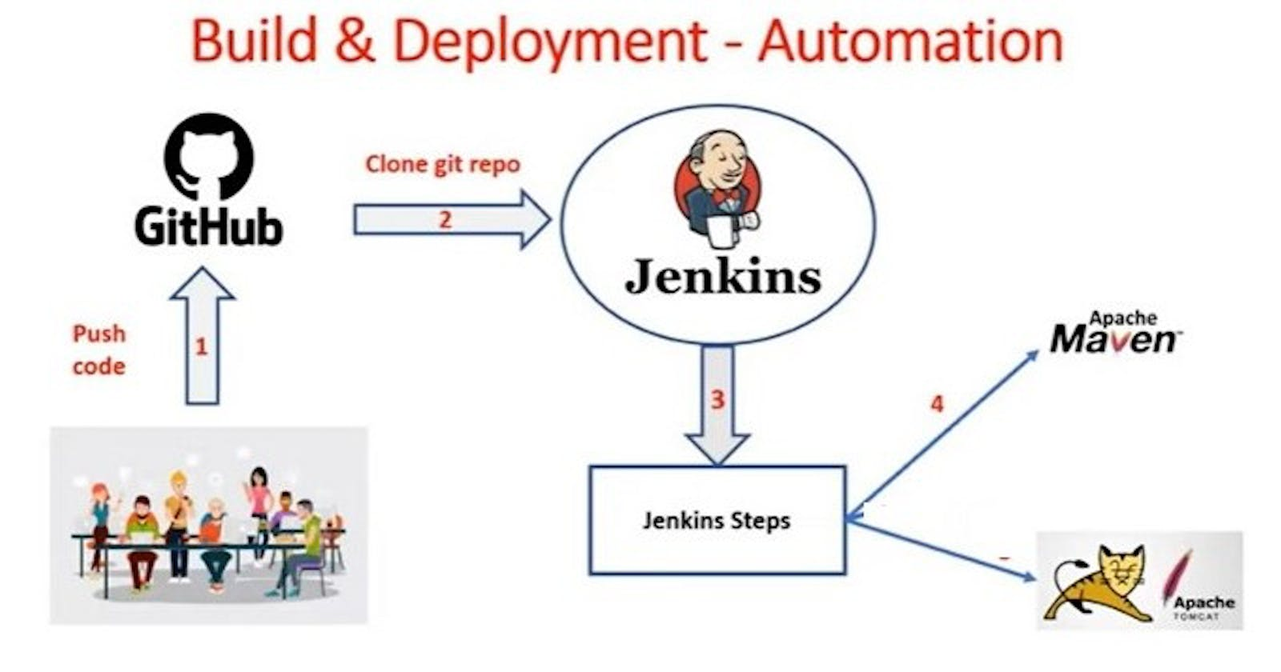

Infrastructure Setup :
-> Create Linux VM using EC2 in AWS cloud and install tomcat server
-> Create Linux VM using EC2 in AWS cloud and install Jenkins server
-> Clone Git Hub Repository
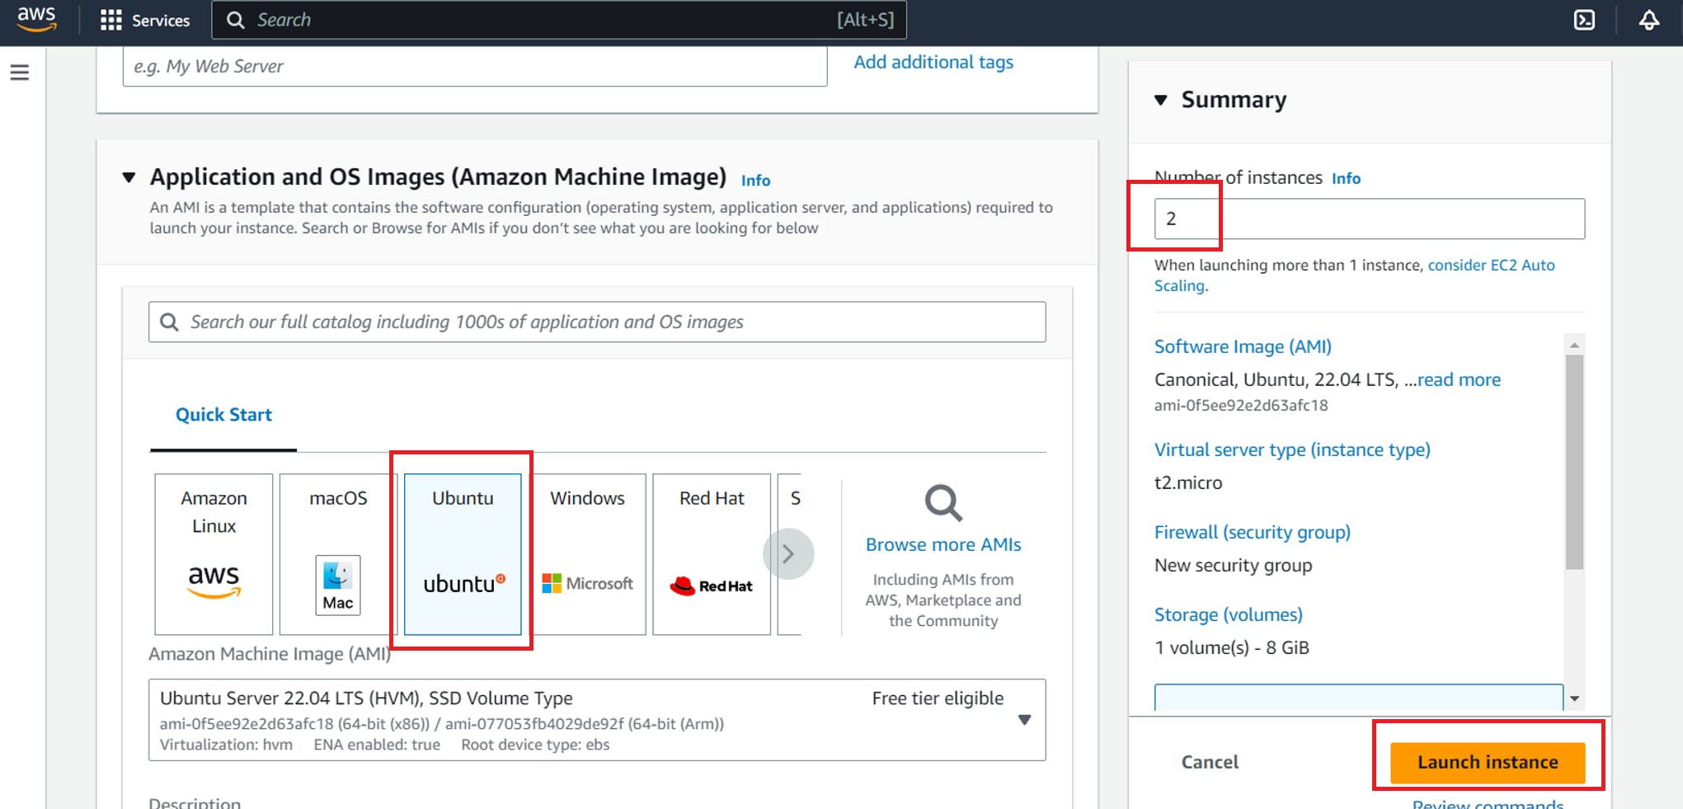
Allow port not 8080 in Security group :
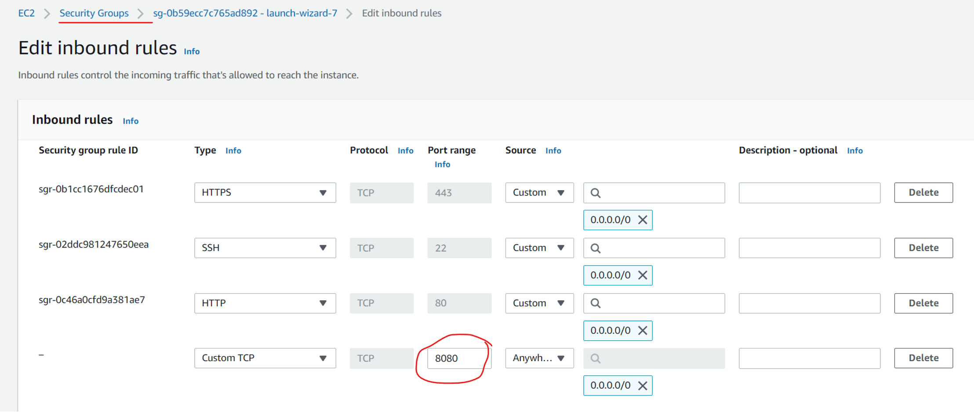

Build & Deployment Process :
Download project from git hub
package the project using maven
Maven will create war file
Deploy war file into tomcat (post build action)
Note: Above build & deployment process can be automated using Jenkins
Access application using URL in browser

Jenkins Job Creation Process :
- Login into Jenkins
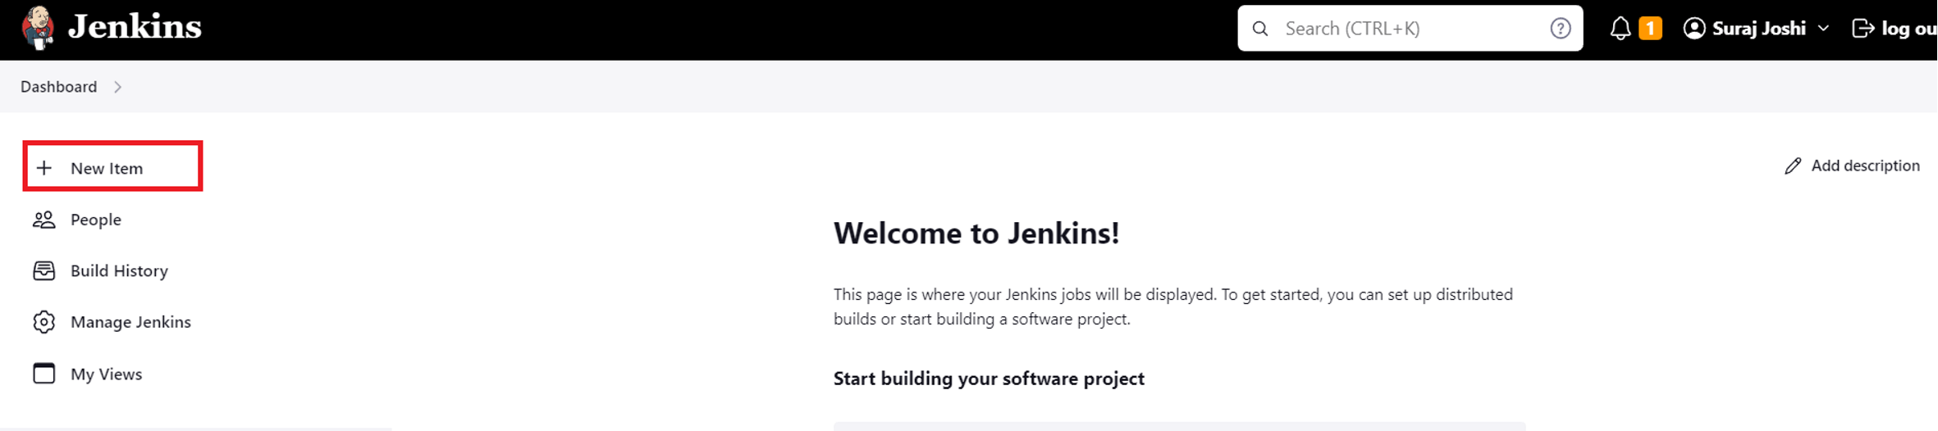
- Configure Maven in Global Tool Configuration (Jenkins will download maven)
-> Manage Jenkins -> Global tools Configurations -> Add Maven
- Install 'Deploy To Container' Plugin (To deploy war to tomcat server)
-> Manage Jenkins -> Manage Plugins -> Go to available tab -> search for 'Deploy To Container' plugin -> Click on install without re-start
Note: Git s/w will be available by default in Jenkins Gloabl Tools Configuration
- Create Free Style Project
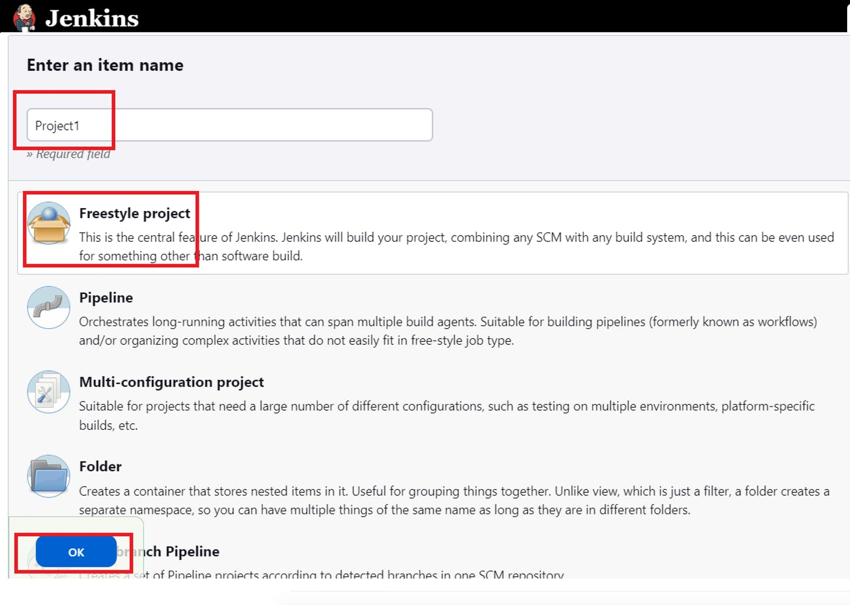
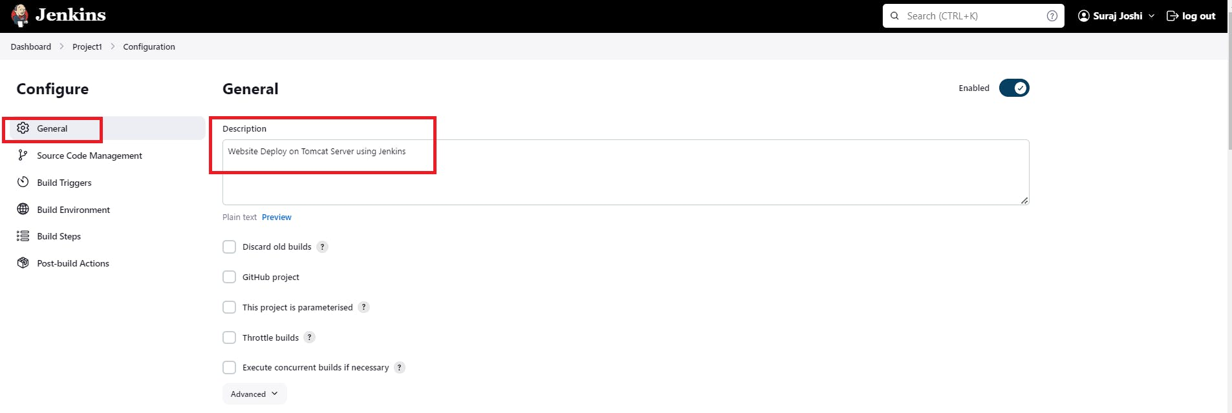
- Enter Git Repo URL
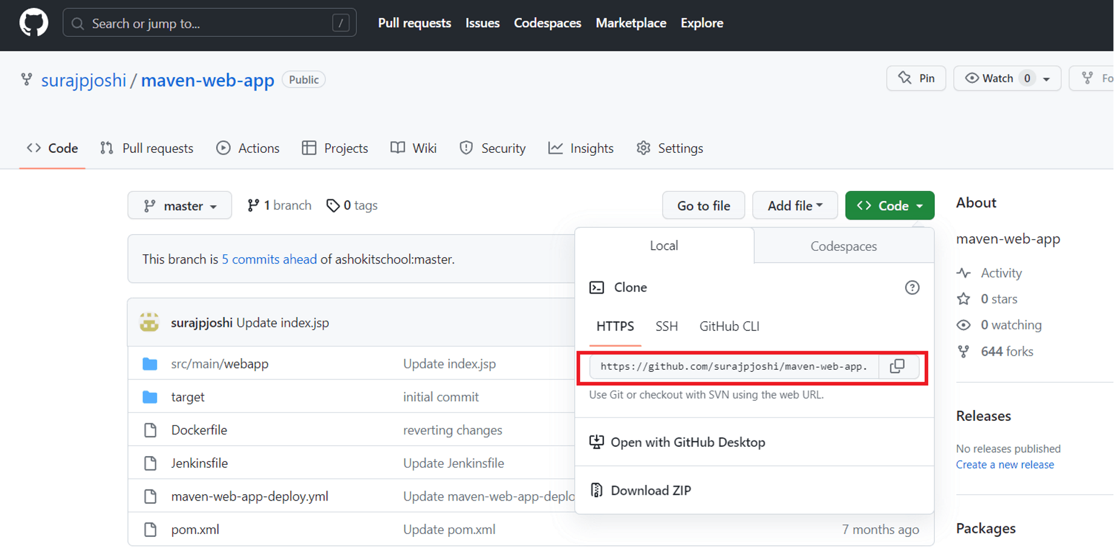
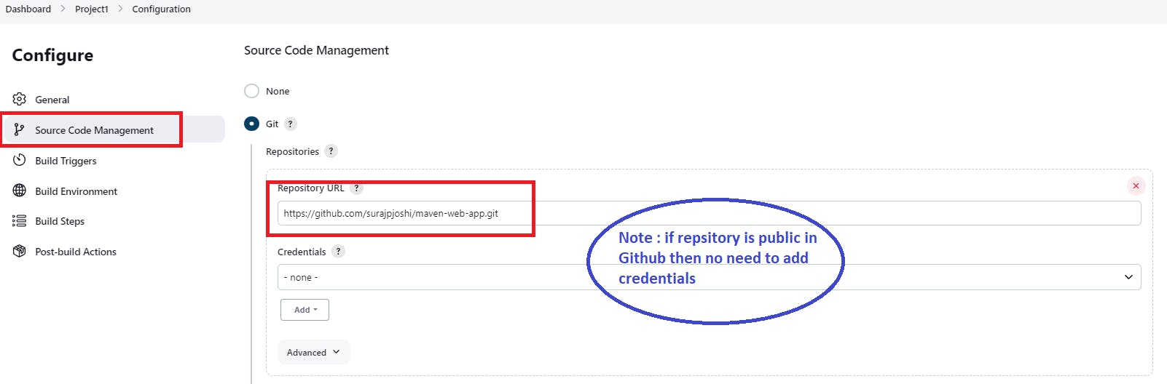
- Build Trigger (configure Maven which is added in Global Tools and Provide Maven Goals as clean package)
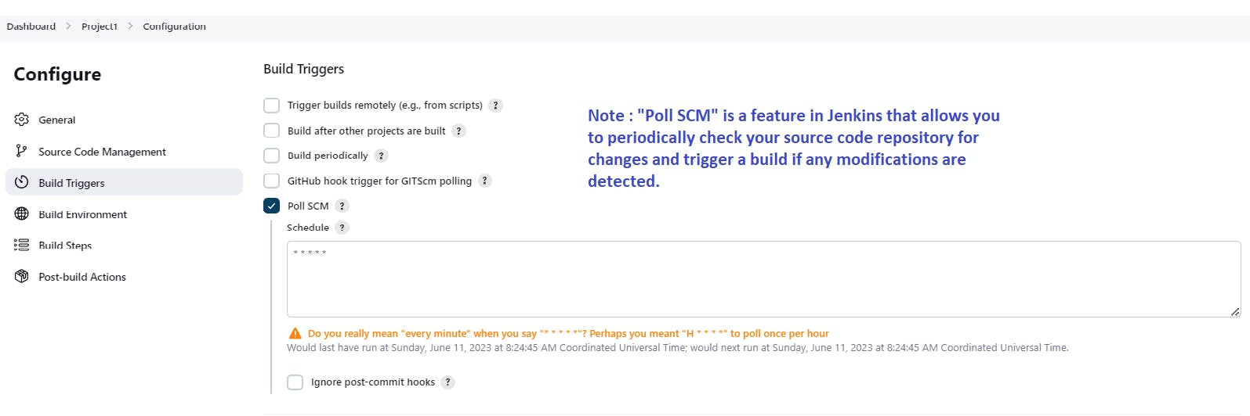
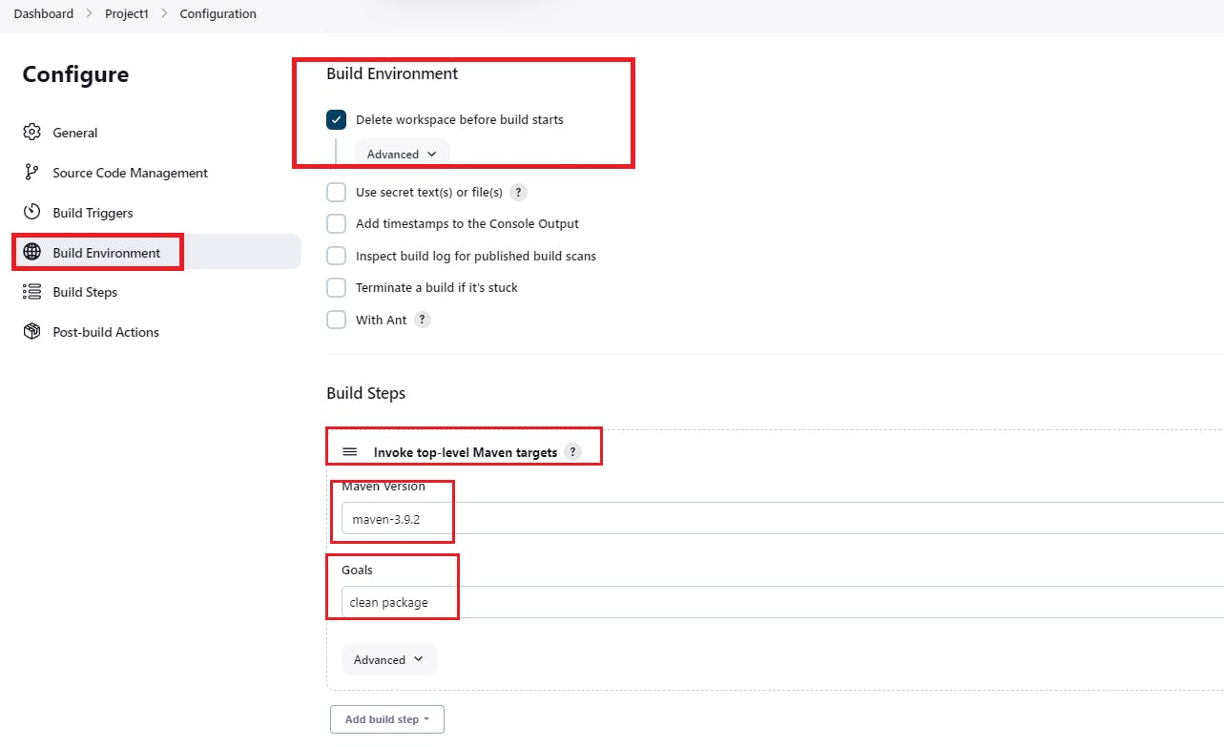
- Add Tomcat Server in Post Build Action For deployment
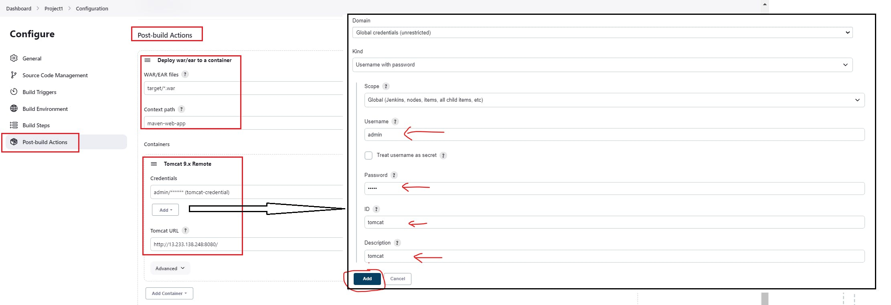
Save the Job configuration

Run the Job :
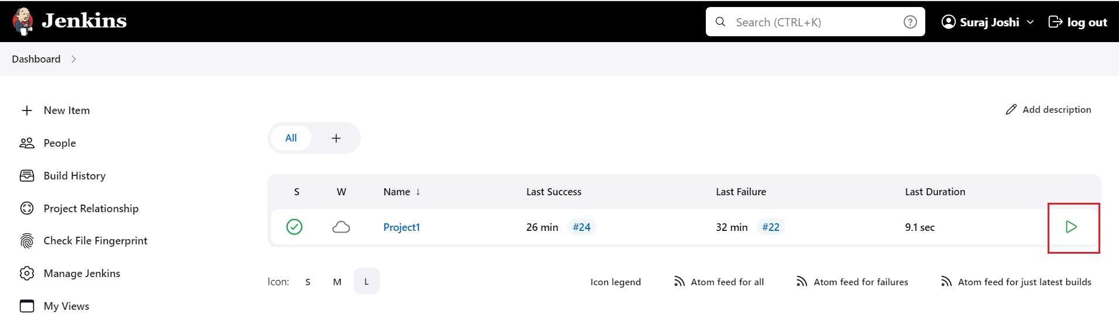
Check the Build Status :
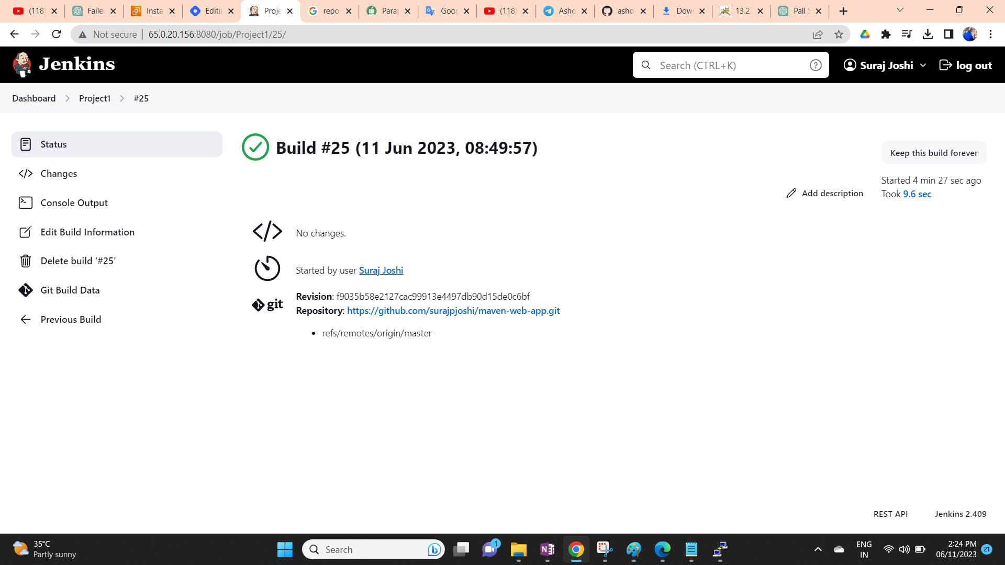

See the Tomcat Dashboard (Application should display) and access the application
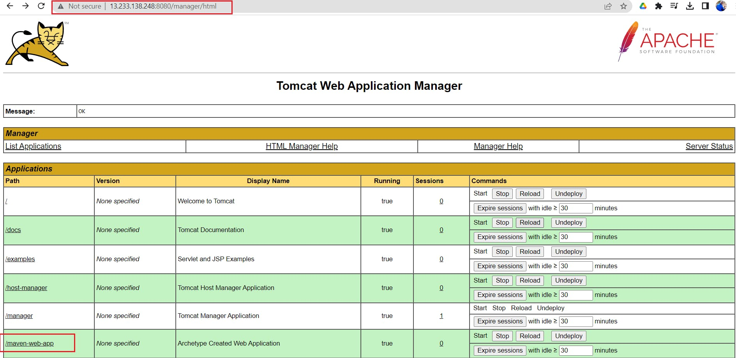
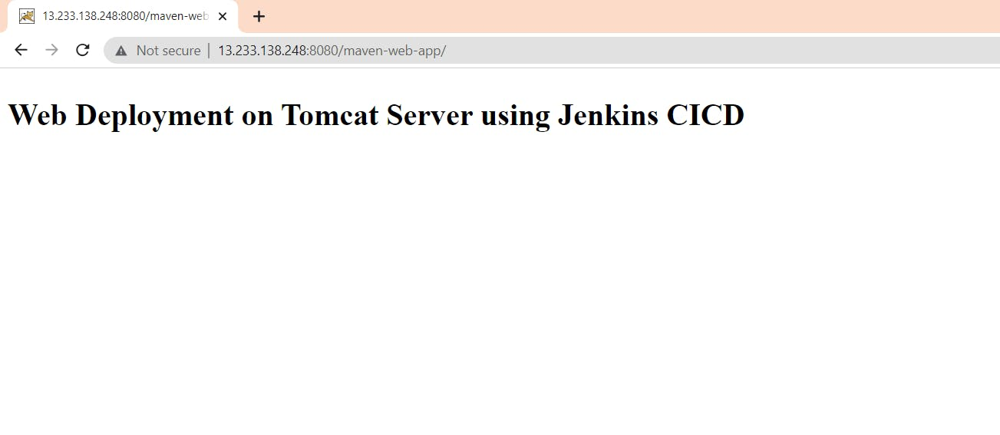
Hope this blog is useful and you can use these resources to configure the CICD pipeline. Thank you

